**BASH CHALLENGES**

There are a total of ***15 questions***. You might face problems with understanding the commands but remember, Google is your best friend.

**Plagiarism should be avoided at all costs!**

**____________________________________________________________**

Do these tasks on your terminal . Create a .md file in your github repo containing qns and the answer where you should have the screenshots of command and necessary outputs.

We will be checking your git repos.

What is a .md file , how to create them?

* [Geeksforgeeks](https://www.geeksforgeeks.org/what-is-readme-md-file/)
* [Medium](https://medium.com/@saumya.ranjan/how-to-write-a-readme-md-file-markdown-file-20cb7cbcd6f)

________________________________________________________________

**man** command is used to display the user manual of a command and it shows detailed information on how to run a command and the multiple options which can be used with the command.

You may need to study the commands mentioned below and learn how to use them for doing the below questions.

If you don't know how to use a command, don't hesitate to view the manual page.

**Note: *Everything must be done on the Command Line Interface.***

(man, pwd, ls, cd, cat, cp, echo, touch, mv, file, mkdir, rm, rmdir, grep, base64, find, nc, ssh, nmap, telnet, ping, wget, curl)

(Note: Questions 1 to 9 are linked to each other)

**1.**

( a.) Display the path of your current directory

( b.) List out the contents of your current directory

( c.) List out the contents of your current directory including hidden files

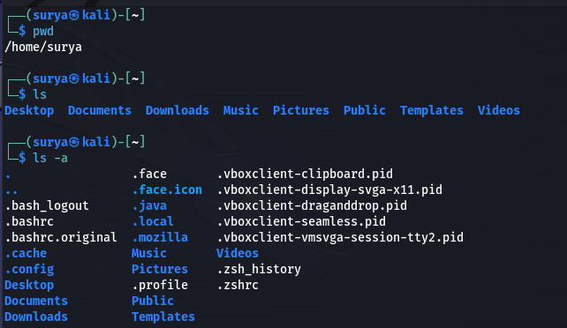

**2.**

( a.) Create a new directory named a

( b.) Move to the newly created directory a

( c.) Create a blank file named “file1”

( d.) Display the file type of “file1”

( e.) Add the line “Hello World” to “file1” using the command echo

( f.) Display the contents of “file1”

( g.) Display the file type of “file1” again

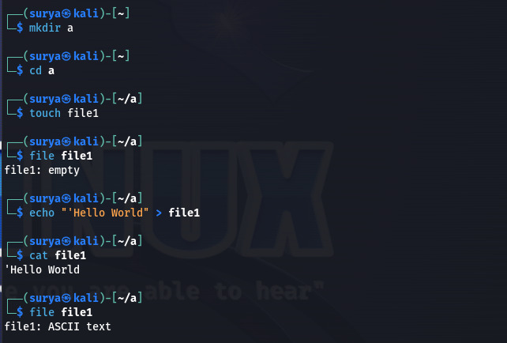

**3.**

( a.) Stay in directory a. Create a file “file2” and add the contents below using the command cat

***First Line Second Line Third Line***

( b.) Display the contents of “file2”

( c.) Display the contents of “file2” with the lines reversed

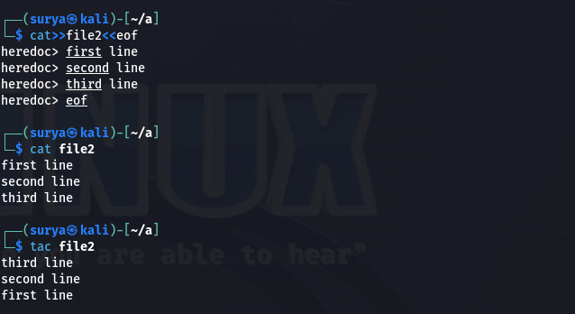

**4.**

( a.) Stay in directory a. Concatenate the contents of “file1” and “file2” and save them into a new file “file3”

( b.) Display the contents of “file3”

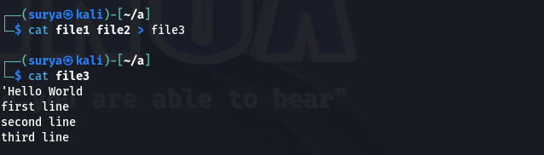

**5.**

( a.) Stay in directory a. Create 2 directories b/c with a single command

( b.) Create a new directory d

( c.) Copy the directory d to directory c using a single command

( d.) Delete the directory d in the current directory a

( e.) Copy “file3” to the directory d with a single command

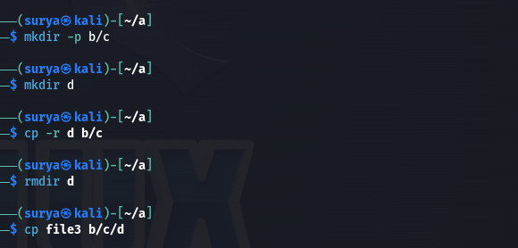

**6.**

( a.) Go to directory d and rename “file3” to “file0”

( b.) Stay in the same directory and move “file0” to directory a

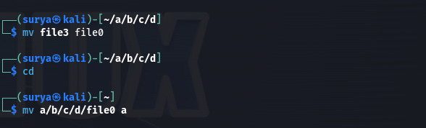

**7.**

( a.) Go to your home directory

( b.) Create a file named “test” in the directory a/b/c/d

( c.) Stay in the home directory. Find and display the path of “test”

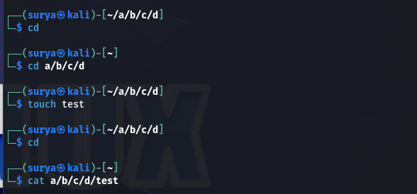

**8.**

( a.) Go to directory a. Get the man page of grep and save its contents to a file named “grepman.txt”

( b.) Print the lines containing the word “FILE” (Case sensitive) in the file “grepman.txt”

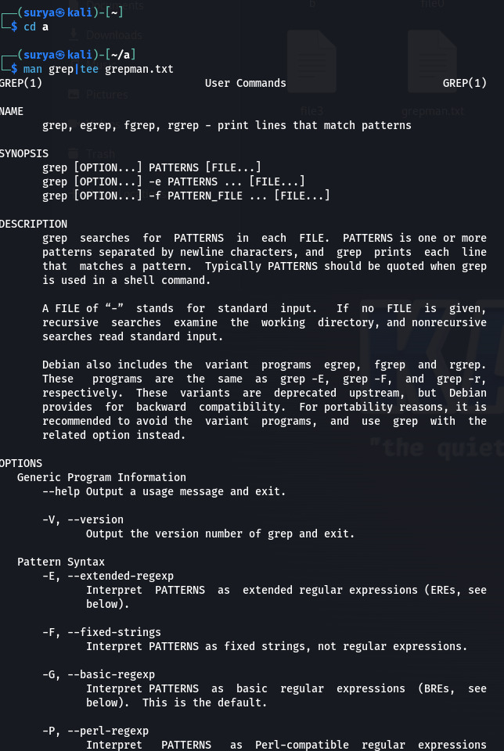

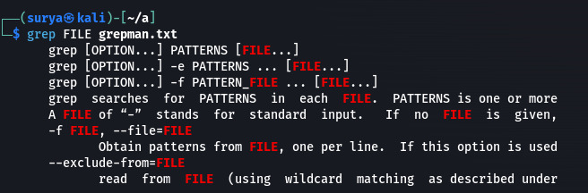

**9.**

**( a.)** Go to directory a and remove the directory b with a single command

**( b.)** Remove the files starting with the word “file” with a single

Command

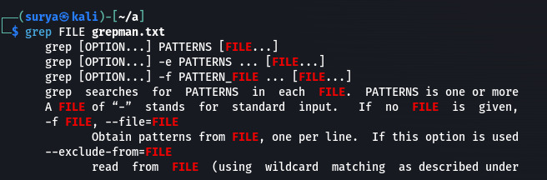



**10.**

( a.) Download the compressed file from the drive. <https://drive.google.com/drive/folders/1PG3ZlpFu6nQSNjpCNuceoGcNey00bhPP?usp=sharing>

( b.) Extract the compressed file using CLI.

( c.) Decode the base64 content and display the content of “Flag.txt”using CLI.

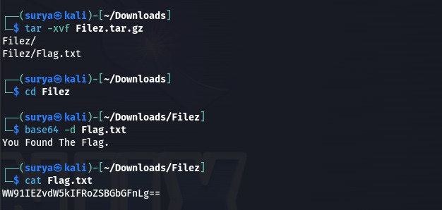

**11**.

( a.) Go to <https://blog.bi0s.in/> and download the logo.png image using wget

( b.) Do the same using curl

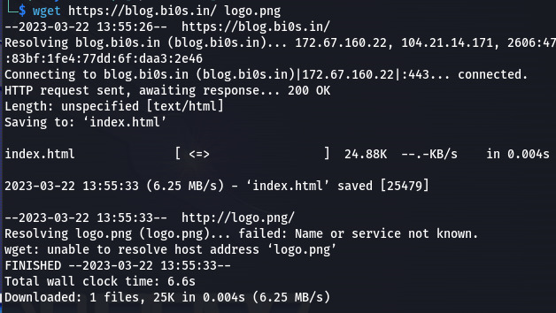

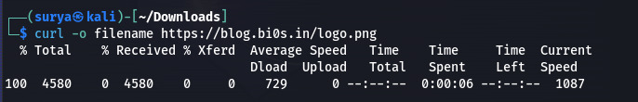

**12.**

**( a.)** Ping google.com and find the lowest time taken to get a response (Stop pinging after getting 5 responses)

**( b.)** Ping google.com 6 times and find the average time taken to get a response

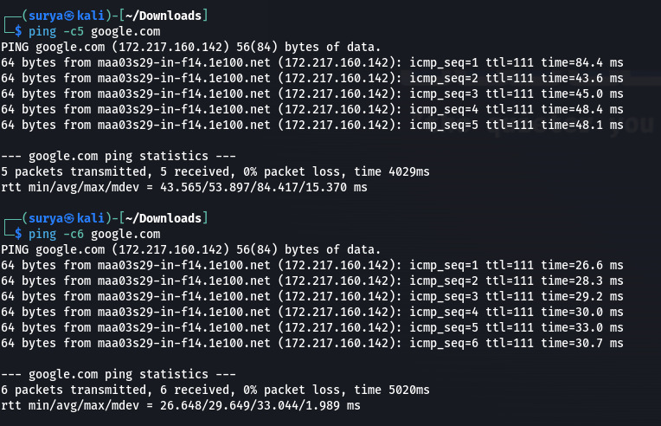

**13.**

Connect to your own system using telnet

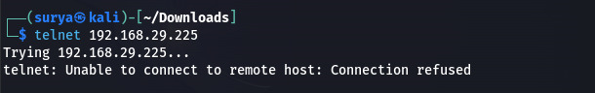

**14.**

( a.) Learn about nmap and use that scanner to scan your own machine

( b.) Use nmap to scan scanme.nmap.org

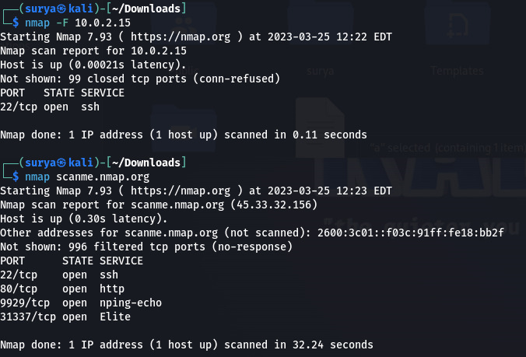

**15.**

( a.) Create a chat application using nc on your local machine with one terminal as server and other as the client

( b.) Transfer a file from server to client (save that file with another name) and display the file.

